The Impact of Income, Gender, and Marital Status on Insurance Claims: A Comparison of OLS, Ridge, and Lasso Regression Models

Introduction
This project investigates how a client's income, gender, and marital status impact the size of life insurance claims. Using a dataset of 500 clients, we compare Ordinary Least Squares (OLS), Ridge, and Lasso regression methods. The goal is to evaluate whether regularization techniques improve model performance when only a few core demographic variables are used. This task is relevant both for applied analysis in the insurance industry and from the point of view of machine learning methods.

Data Description and Analysis Process
A dataset comprising 500 records was utilized to extract client information. Although 18 features were initially considered, subsequent analyses focused specifically on three key variables: income level, gender, and marital status. These variables are often informative in insurance-related calculations and are relatively straightforward to replace or anonymize.
Prior to model development, the dataset underwent preprocessing. Notably, the variable representing insurance experience (FACE) contained significant errors and was excluded from the analysis. Additionally, the FACE and INCOME variables were log-transformed to address skewness and mitigate issues related to non-normal distributions.
The dataset was then randomly split into training and testing subsets. Three modeling approaches were applied: OLS, Ridge regression and Lasso regression.
In the OLS model, income emerged as the dominant predictor, with higher income levels corresponding to increased predicted insurance payments. The Ridge regression model, with a regularization parameter of α = 39.07, yielded the same mean squared error (MSE = 2.7158) as linear regression but produced slightly more regularized coefficient estimates: income (0.618), gender (0.249), married (0.225), and single (-0.092).
The Lasso regression model, employing a regularization parameter of α = 0.0868, confirmed the importance of income (coefficient = 0.734) and gender (0.199), while nearly eliminating the influence of one marital status category (coefficient = -0.005). This is characteristic of Lasso’s ability to perform feature selection by shrinking irrelevant feature coefficients to zero. Despite these differences in model behavior, all three approaches achieved the same average error (MSE = 2.7158).
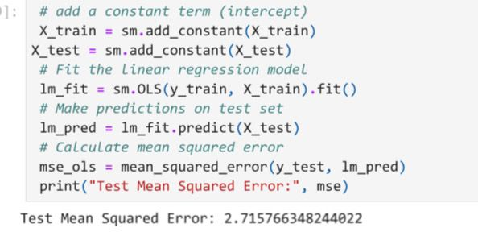
OLS model
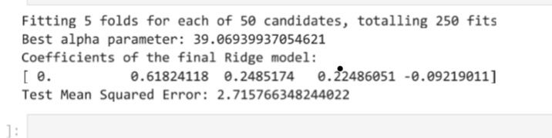
Ridge model

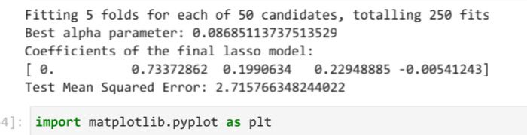
Lasso model
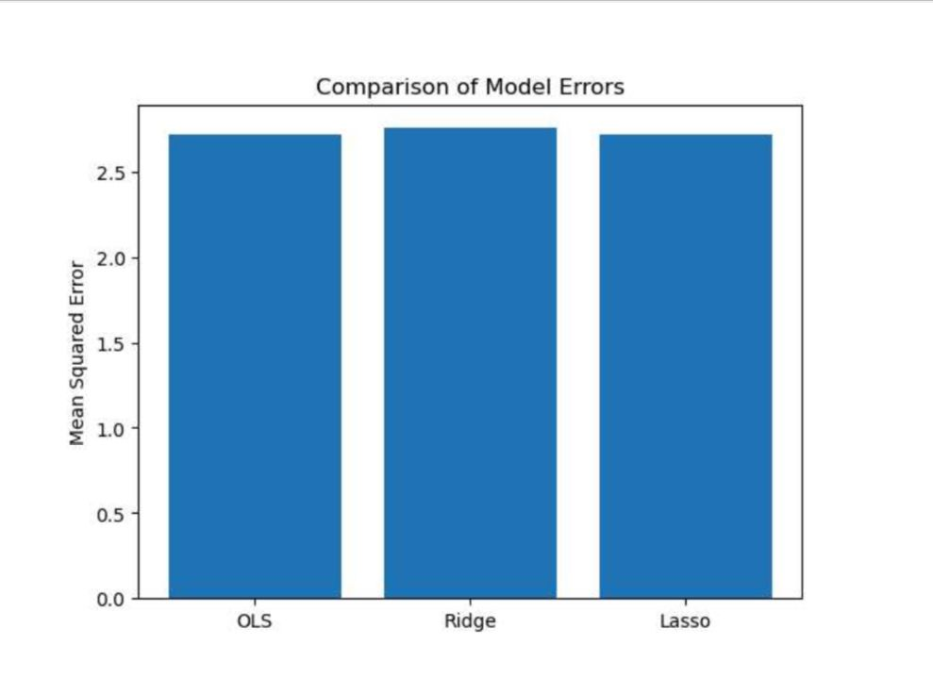

Conclusion
The results are that all three models - both without regulation and with it - gave the same accuracy in selecting tests. This can be explained by the fact that we used only three variables, there was no independence between the participants, and the problem itself turned out to be quite linear. In addition, after removing incorrect records, only 275 conclusions remained, which is enough for overfitting to occur. Therefore, even a simple model without regulation coped with the state no worse. However, Lasso is several simplified models that have one minor feature and do not correspond to accuracy. This makes the result more stable and easier to understand. To further improve the quality of predictions, one can use a set of criteria that link the relationships between them, use cross-sectional studies, and test more flexible models that can detect non-linear patterns.

